Balancing Energy
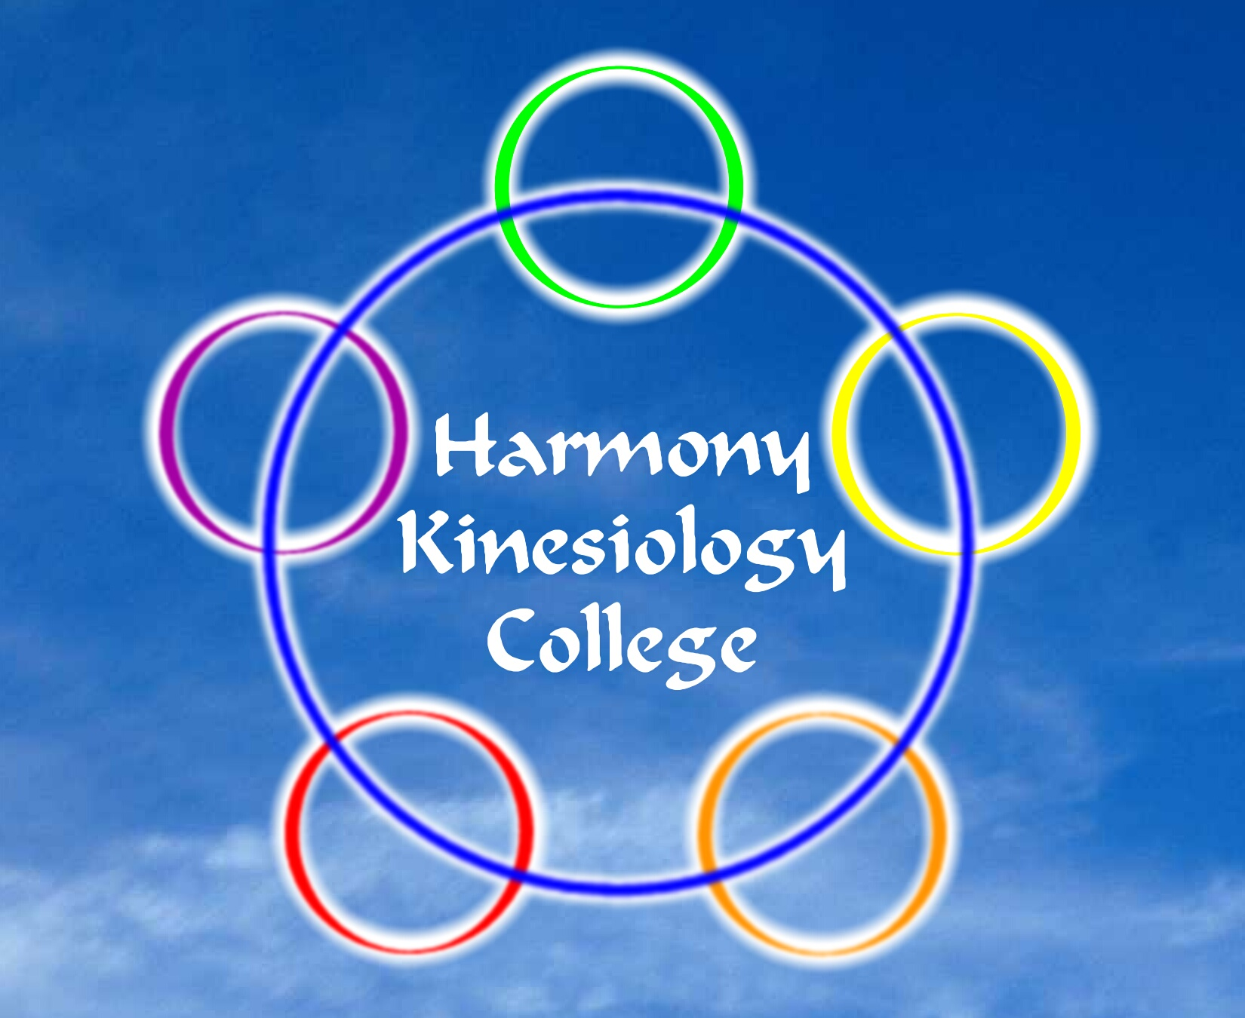
Using Sound Frequency

This class introduces methods of balancing the body’s energy systems using sound frequency to enhance well-being.
Modalities included are sound tuning forks, sound frequency tone generator and other sound balancing options.

2nd & 3rd April 2022 from 9.30am – 5.00pm

£230.00

Venue
Harmony Kinesiology College
575 Anniesland Road, Scotstounhill, Glasgow G13 1UX
Tel: 0141 959 2042 or 0141 954 1796

Class will run subject to sufficient applicants attending class

............detach................Return Form Below ...........detach.............

Balancing Energy Using Sound Frequency – 2nd & 3rd April 2022

Course Level

Date(s)

Name

Address

E-mail | Mobile
I will make payment by.... Debit / credit card [ ] Cash [ ] tick as appropriate
Please do not post cash
Credit Card No. | Expires | Please phone to process security code
Bank Payment Details | Account Name | J Currie
Bank Transfer: Co-operative Bank | Account: 68051185 | Sort Code: 08-92-50
Signed | Date
Return to... Harmony College, 575 Anniesland Rd, Glasgow G13 1UX

