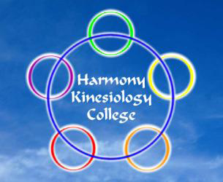
Harmony
Emotional Balancing
Course Level 2

It is widely recognised that emotional stress can be the underlying cause of many behavioural challenges and physical symptoms.
This class expands the knowledge learned in Level 1 and introduces more skills to enhance the balancing of emotional stress and to ease associated conditions.
This class deepens insights and introduces processes to enhance natural healing potential.
07 & 08 August 2021
£230.00

Harmony Kinesiology College
575 Anniesland Road, Scotstounhill, Glasgow G13 1UX
Tel: 0141 959 2042 or 0141 954 1796

Class will run subject to sufficient applicants attending class

...............................detach.....................return form to address below......................detach or email to......................
info@harmonynaturalhealth.co.uk

Harmony Emotional Balancing Course Level 2 - 07 & 08 August 2021

Name

Address

 |  | Postcode
E-mail |  | Mobile
*I wish to pay by Bank Transfer |  | I wish to pay by Card*
Bank Transfer: Co-operative Bank  Account Name: James Currie |  | Account: 68051185 | Sort Code: 08-92-50
* If you would like to pay by debit or credit card, please phone 0141 959 2042

Signed |  | Date

Return to: Harmony College, 575 Anniesland Rd, Glasgow G13 1UX

